## Acquiring New Targets

### Subtask 1

Create a new user. Give him a short 3-4 letter password. Use crunch to create a dictionary, and then use hashcat to recover the password. You should submit the following.

1. A screenshot of your shadow file showing your new user and his hashed password.

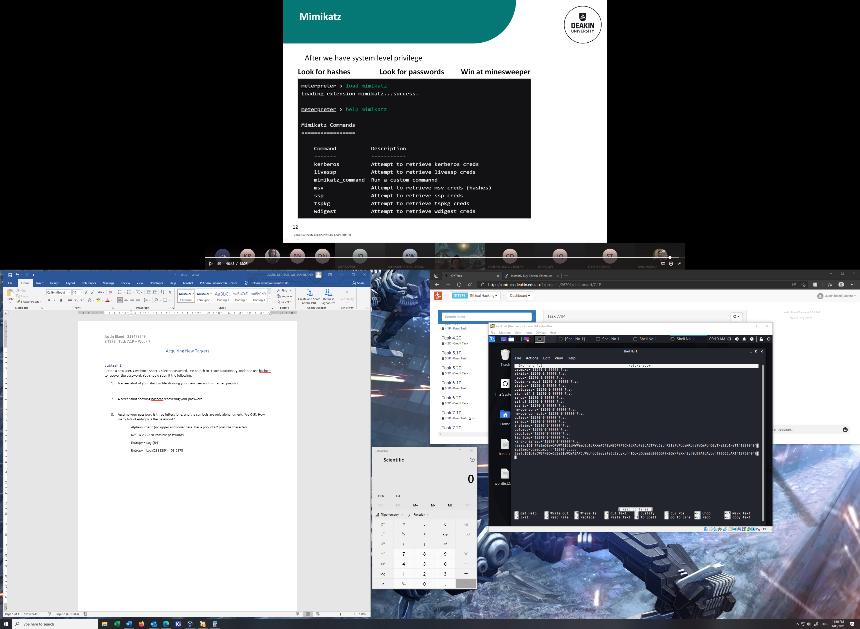

1. A screenshot showing hashcat recovering your password.

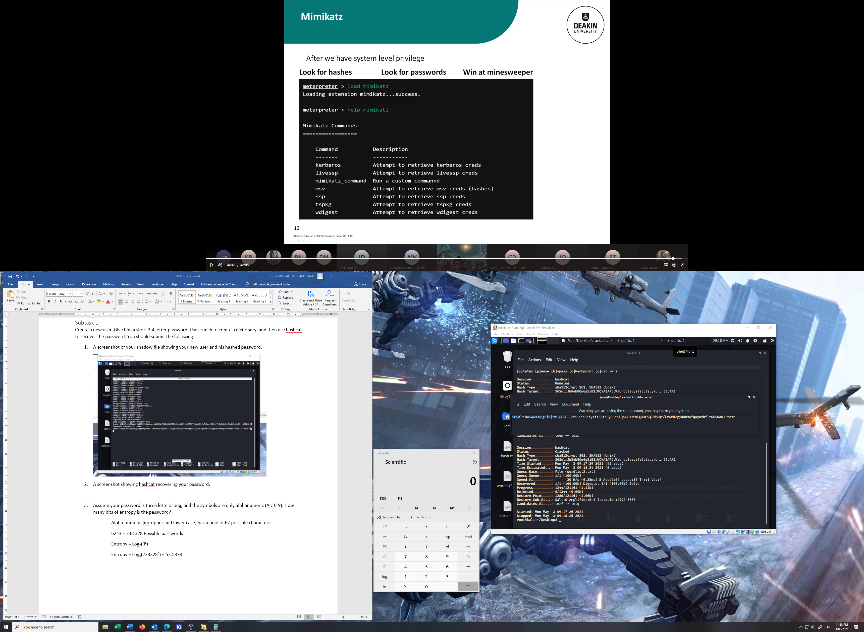

1. Assume your password is three letters long, and the symbols are only alphanumeric (A-z 0-9). How many bits of entropy is the password?

Alpha-numeric (inc. upper and lower case) has a pool of 62 possible characters

62^3 = 238 328 Possible passwords for a 3-character password

Entropy = Log2(R)

Entropy = Log2(238328) = 17.8626